This second assignment is an extension of the first. Instead of using a lambda function in Amazon cloud to provide the functionality for your Alexa Skill, we will use IBM Cloud’s equivalent of lambda functions, and instead of programming utterances into the Alexa Skill, we will let Watson Assistant handle understanding what is said and what the meaning is.

You should STILL be able to ask your Alexa Skill:

1. Who your team members are
2. Another question related to class or your group
3. Another question related to class or your group

And your Alexa Skill should be able to give an appropriate response.

You will need a free IBM Cloud education account to work on the IBM part of this assignment. To do this:

1. Go to the following Auburn University Store link to get your free IBM Cloud Promo Code  
   <https://e5.onthehub.com/WebStore/Welcome.aspx?shiblogout=true&ws=b358730a-e638-de11-b696-0030485a8df0>   
   You will need to sign in with your Auburn Email id and get the IBM Cloud Promo Code
2. Create a trial account in IBM Cloud here: <https://cloud.ibm.com/login>
3. Once you’ve created your account, go to **Manage > Account > Account Settings** and scroll down to feature codes. Select **Apply Code** and paste the code you received when you checked out the IBM Cloud Promo Code from the Auburn Store.   
   (See screenshots below)
4. ~~When you create your IBM Cloud application, instead of using their gitlab repo, I want you to copy the code into YOUR OWN github repo and use that as the storage point for your code.~~   
   Host your code in your own github repo. I still want the link. If you follow the tutorial linked in the announcements (It’s a great starting point), you will see that they actually ‘develop’ the code locally, then they “package” the code up into a zip file that they name action.zip. From there you will need to use the command line tools to use that zip file as the base for your cloud function. (it will create the cloud function for you using that zip file). You will still need to modify the action just like I showed you in class.

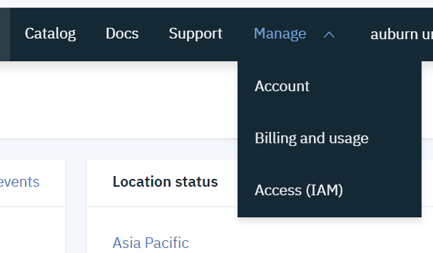

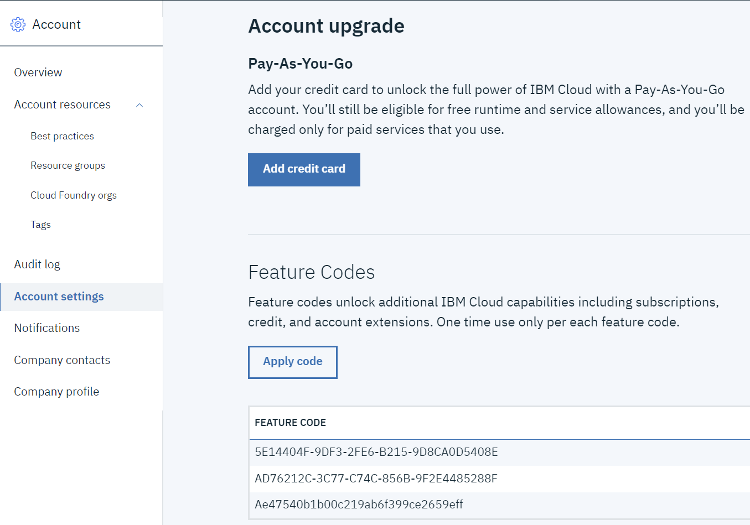

## Deliverables (What should you submit to Canvas)

**ONLY THE TEAM LEADER SHOULD SUBMIT ITEMS 1 - 4**

1. Screenshots showing your Intents (there should be ONLY one), slots (Again, there should be only 1, that you will use to forward information to Watson Assistant), and your configured endpoint (it should point to some HTTPS endpoint that is your IBM Cloud entry point)
2. Screenshots of the intents you’ve created in Watson Assistant and the dialog nodes associated with them.
3. A link to your github repo containing the code for your program’s functionality for your IBM Cloud function
4. A short video recording showing a group member testing your app on the echo that was assigned to your group
5. A short video recording show a group member testing your app on your phone, via the alexa app

**EVERYONE MUST SUBMIT GROUP EVALUATION FORM**

1. Group evaluation form